Project Design Phase-II Technology Stack (Architecture & Stack)

|  |  |
| --- | --- |
| Date | 1 November 2022 |
| Team ID | PNT2022TMID27896 |
| Project Name | Emerging Methods For Early Detection of Forest Fires |
| Maximum Marks | 4 Marks |

Technical Architecture for early detection of forest fire:

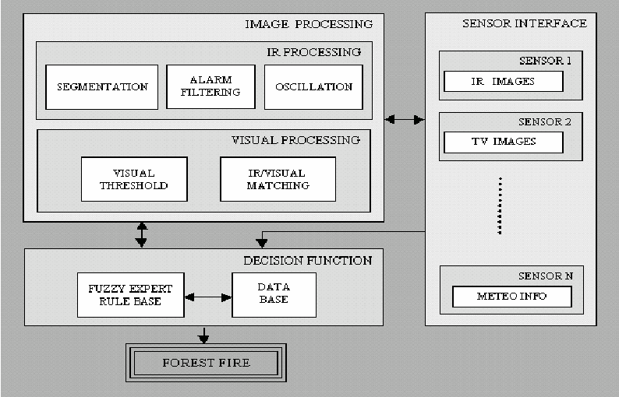

Table-1: Components & Technologies:

|  |  |  |  |
| --- | --- | --- | --- |
| **S.No** | **Component** | **Description** | **Technology** |
| 1. | User Interface | Cost-effective, flexible, secure and uses open-source technologies. | Python Programming |
| 2. | Application Logic | Fuel moisture monitoring with remote sensing for improved fire danger prediction. | My SQLand Python programming. |
| 3. | Database | .  Wild fire, fuel structure, fuel models, allometric models, Fire Paradox | Advanced Very High Resolution Radiometer |
| 4. | Cloud Database | The aftermath leaves a heavy toll on the local environment, economy, and human well-being. | Drones, robots, and satellites |

Table-2: Application Characteristics:

|  |  |  |  |
| --- | --- | --- | --- |
| **S.No** | **Characteristics** | **Description** | **Technology** |
| 1. | Open-Source Frameworks | Forest fires are one of the most dangerous events, causing serious land and environmental degradation | Geographic Information System (GIS) |
| 2. | Scalable Architecture | These complex applications are  either time- and mission-critical applications with stringent requirements | Edge computing |
| 3. | Availability | While firefighting has largely remained unchanged, high-tech solutions are changing how wildfires are battled | distributed servers |
| 4. | Performance | Wireless sensor network (WSN) is a suitable network to give a quick signal on the outbreak of a forest fire in the target area | number of requests per sec |